Token creation instructions
Contenido
First time making token. 1
Create new provider 1
Create new business unit 2
Create session 3
Get session ID 3
Get session keys 3
Get public key 4
Get private key 4

First time making token.
Sign up in paymentsOS, if needed create your own account.
https://control.paymentsos.com/signup
in sample, the user/password created are:
user: evan.guerrero@hotmail.com
password: Patosh2012

Create new provider
Step | Screen | Detail
1 | 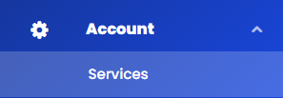 | Move to Account/services
2 | 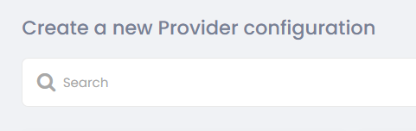 | Select “Create a new provider configuration”
3 | 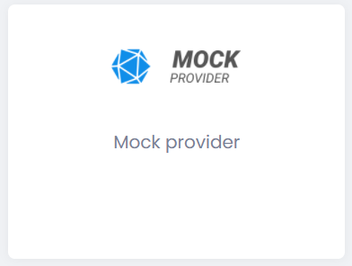 | Select MOCK provider
4 | 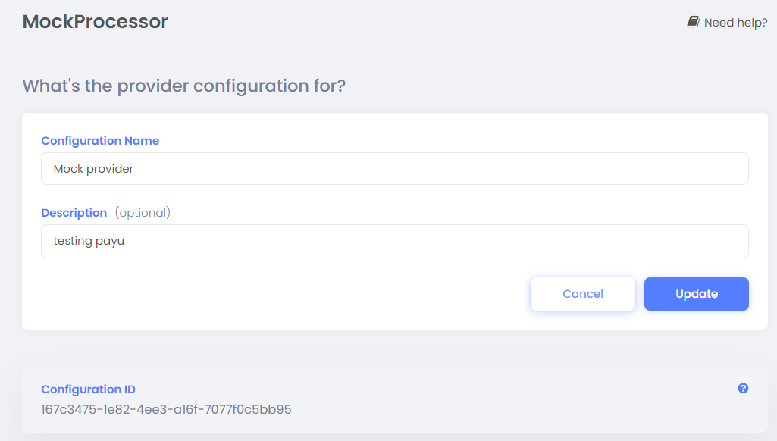 | Add a configuration name and a description.

Create new business unit
Step | Screen | Detail
1 | 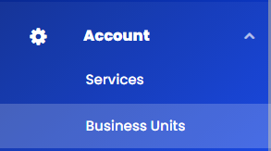 | Move to Account/business units
2 | 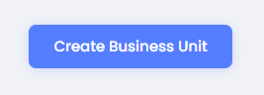 | Select Create business unit
3 | 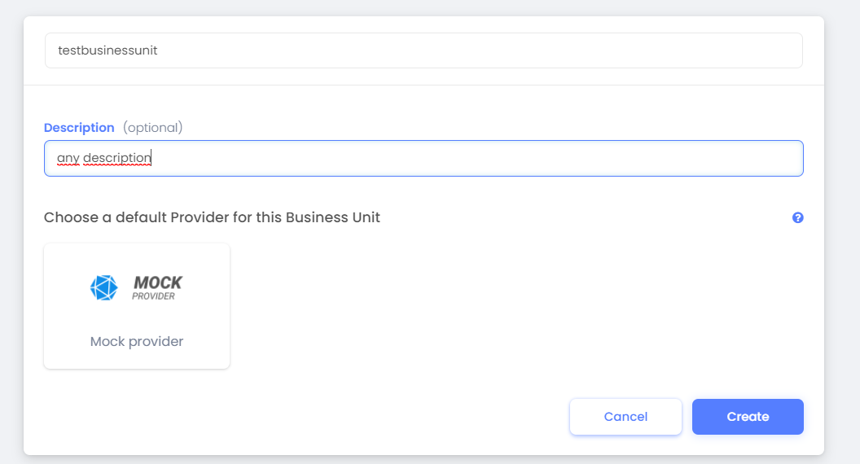 | Write a name, in the example “testbusinessunit” this is important for the app-id in the messages, for example com.payu.colombia.testbusinessunit,  Then, choose the default provider for the business unit, in this case MOCK provider, and select  CREATE.

Create session

Get session ID
Perform session using the login information in PaymentOS tool:
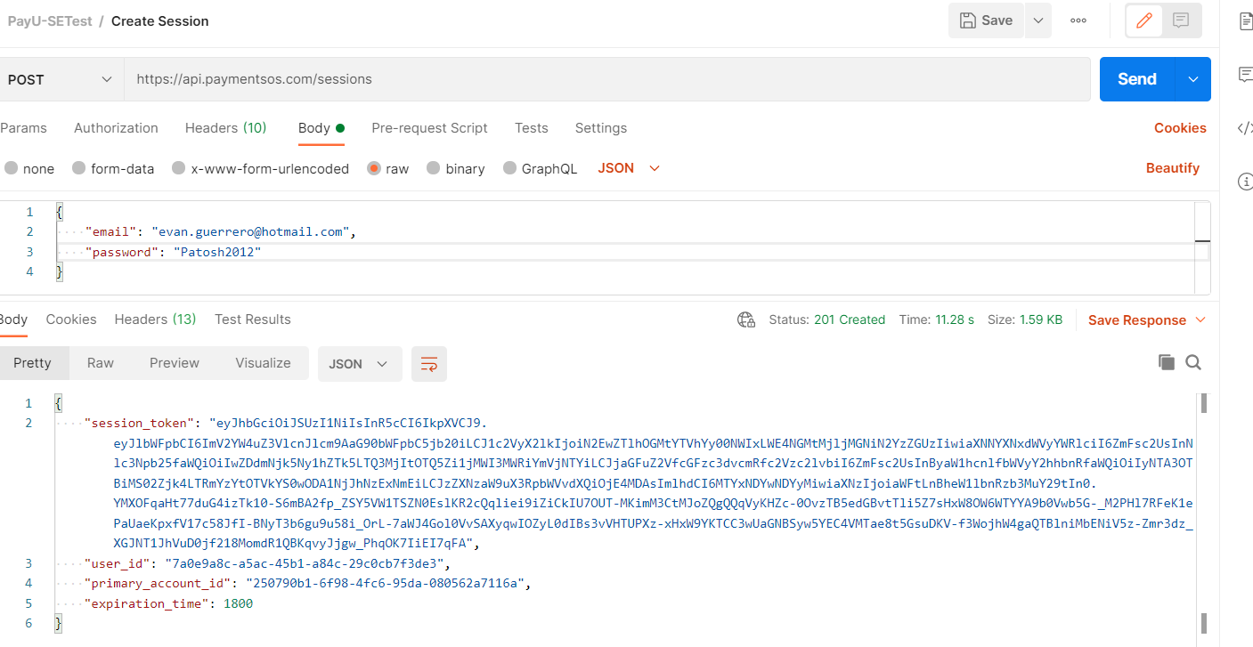

Get session keys
For the next steps keep in mind the following instructions:
The field session_token, is a bearer token you must configure in Authorization field.
In headers, after account, type the primary_account_id received in Get session Id response, then after apps, select com.payu.colombia.<your_business_unit> created in “Create new business unit” info.

Get public key
Change parameter type for “public”
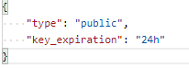
and the response will be used as public-key header for next transactions.
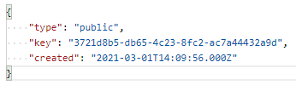

Get private key
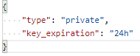
and the response will be used as private-key header for next transactions.
